Girls Inc.

Kayleen Malizzi

K – 1st Grade

Social Studies Unit

**Table of Contents:**

Overview – 3

Background Information – 3-4

Unit Objectives – 4-5

Vocabulary – 5-7

Initiation – 7

Individual Lessons – 7-26

Bulletin board Sketches/Pictures – 27

References – 27

Reflection – 28

**Overview**

I had the opportunity to work with Kindergarten and First grade students from the Girls Inc. program in Omaha, Nebraska, and focused on applying Social Studies to real life. By showing the girls how Social Studies is used for understanding how we as community and as good citizens can keep our’ communities/ environments safe by Reducing, Reusing, and Recycling. I was able to help the students understand and enjoy Social Studies by using activities such as literature, art, and technology. Students were able to use proper Social Studies techniques, remember what they learned, and apply concepts to today to help them tomorrow.

**Background Information**

In choosing lessons I looked at a wide variety of ways Social Studies is applied every day. I had my students focus on concepts of recycling which includes the three “R’s” (Reduce, Reuse, and Recycle). We as a class were able to zoom in on each of the “R’s” of recycling and were able to apply them to our daily living environments and habits. Also we applied what we learned and were able to apply the three “R’s” of Recycling to *Dr. Seuss’ The Lorax.*

I made sure to included literature, art, technology, and a service learning project for the girls to partake in. This helped them actively apply what they learned.

We used art, literature, social science several times, because they so easily integrate with science. For example, my students did a flower labeling activity using art supplies such as construction paper, glue, scissors, yarn, and raw material such as pinto beans to make a sunflower.

**Unit Objectives (Just Science – not math, lit., etc.)**

Lesson One: **Saving Our Planet with REDUCE, REUSE, AND RECYCLE**

Students will be able to:

Will analyze the characters and events in *The Lorax* by Dr. Seuss, drawing comparisons between the stories fictional environment and our environment we live in today.

Will discuss ways to positively impact the environment.

Will be able to list items that can be REDUCED

Will be able to list items that can be REUSED

Will be able to list items that can be RECYCLED

Describe what reduce, reuse, and recycling means.

Describe how reducing, reusing and recycling items can save our plants environment.

Will be able to explain what garbage is and how it is different than reduced, reused, and recycled items.

Lesson Two: **All About Ronald**

Students will be able to:

Explain how they can as members of the community can help save the environment by Reducing, Reusing, and Recycling.

Describe to others what the Ronald McDonald House’s mission is.

Persuaded others to get involved with helping save our environment.

Persuaded others to get involved with helping collect pop tabs for the Ronald McDonald House.

Create posters to help spread awareness about needing to reduce reuse and recycle.

Create posters to help fundraise for the Ronald McDonald House. (By collecting pop tabs)

Decorate boxes to help with fundraising for the Ronald McDonald House. (So people can put pop tabs in.)

Lesson Three: **Recycle with Technology**

Students will be able to:

Students will be able to compare and contrast between the three “R’s” Reduce Reuse and Recycle.

Will discuss ways to positively impact the environment.

Will be able to list items that can be REDUCED

Will be able to list items that can be REUSED

Will be able to list items that can be RECYCLED

Describe what reduce, reuse, and recycling means.

Describe how reducing, reusing and recycling items can save our plants environment.

Will be able to explain what garbage is and how it is different than reduced, reused, and recycled items.

Lesson Four: **My Humble Abode**

Students will be able to:

Students will understand that there are many different habitats for humans, animals, and things.

Student will create a poster of their own habitat/ home they live in with scraps of paper.

Students will be able to categorize items that can be reduced, reused, recycled, or thrown away in the trash.

**Vocabulary**

REDUCE: make smaller or less in amount, degree, or size.

REUSE: use again or more than once.

RECYCLE: convert (waste) into reusable material.

POLLUTION: the presence in or introduction into the environment of a substance or thing that has harmful or poisonous effects.

CHEMICAL: a compound or substance that has been purified or prepared, especially artificially.

HOUSE: a building for human habitation, especially one that is lived in by a family or small group of people

APARTMENT: a suite of rooms forming one residence, typically in a building containing a number of these.

CONDO: a building or complex of buildings containing a number of individually owned apartments or houses.

SPLIT-LEVEL HOME: (also called a tri-level home) is a style of house in which the floor levels are staggered, so that the "main" level of the house (e.g. the level that usually contains the front entry), is partway between the upper and lower floors.

TOWNHOUSE: A tall, narrow, traditional row house, generally having three or more floors.

URBAN: in, relating to, or characteristic of a city or town.

RURAL: in, relating to, or characteristic of the countryside rather than the town.

SUBURBAN: an outlying district of a city, especially a residential one.

POPTABS: ring pull on a beverage can such as on a Coca Cola or Pepsi can.

RONALD MCDONALD HOUSE: housing option for families when they are away from home and their child needs medical care.

COLLECTING: bring or gather together (things, typically when scattered or widespread).

SERVICE: the action of helping or doing work for someone.

POUND (lbs.): a unit of weight in general use equal to 16 oz. avoirdupois (0.4536 kg).

**Initiation:**

I made sure to involve the girls in group/class discussions with each other, while asking them a leading question to make sure they followed the right idea/subject. I had them talk back and forth to each other of what they thought. Another activity I had the girls do was if someone was finished with their work early I had them help a friend work with a classmate that wasn’t finished yet as long as they asked permission to help their classmates first. Though the girls mainly did a lot of class discussion, so they always had the chance to talk. I used drawing sticks to call upon the girls so it made it fair for each students to speak/ give an answer to my questions or topics.

**Lesson Plans:**

**Saving Our Planet with Reduce, Reuse, and Recycle**

|  |  |  |  |  |
| --- | --- | --- | --- | --- |
| **LESSON/ACTIVITY INFORMATION** | | | | |
| **Title: Saving Our Planet with Reduce, Reuse, and Recycle** | | | | |
| **Your name: Kayleen Malizzi** | **Age or Grade Level:**  **K-1st grade** | | **Integrated Disciplines/Subjects:**  **Natural Science/The Environment** | **Time frame for Lesson: 45 to 60 minute lesson** |
| **STANDARDS, OBJECTIVES, ASSESSMENTS & MATERIALS** | | | | |
| [**Nebraska State Standards**](http://www.education.ne.gov/academicstandards/index.html)**;** [**Nebraska Early Learning Guidelines**](http://www.education.ne.gov/OEC/elg.html) **and** [**NET-S**](http://www.iste.org/docs/pdfs/nets-s-standards.pdf?sfvrsn=2) **(as appropriate for the lesson):**  **SS 0.3.5.b Give examples of how to care for the environment (e.g., recycle cans, bottles, and paper; pick up your trash)**  **SS 1.2.2 Students will identify natural resources.**  **SS 1.2.6.a Give examples of situations where students and families have chosen to save for future purchases**  **SS 1.3.4.b Describe places in the community (e.g., farms, parks, houses, stores)**  **SS 1.3.5.c Identify environmental issues related to the physical environment (e.g., drought, poor soil development, deserts, terrain)** | | | | |
| **Objectives:** *Make certain to include When, Who, What and How (criterion for success) in your objectives. You may find terms related to* [*Bloom’s Taxonomy of Cognitive Development*](http://img.docstoccdn.com/thumb/orig/27373481.png) *helpful in formulating your objectives. Sample lead in phrases for writing learning objectives are listed below.*  During the activity, the child will be able to:  **OR**  The students will be able to:  Will analyze the characters and events in *The Lorax* by Dr. Seuss, drawing comparisons between the stories fictional environment and our environment we live in today.  Will discuss ways to positively impact the environment.  Will be able to list items that can be REDUCED  Will be able to list items that can be REUSED  Will be able to list items that can be RECYCLED  Describe what reduce, reuse, and recycling means.  Describe how reducing, reusing and recycling items can save our plants environment.  Will be able to explain what garbage is and how it is different than reduced, reused, and recycled items. | | | | |
| **Assessment:** *Must link to the objective above – assessments can be either formative or summative. You must clearly describe strategies and tools used to document student learning.*  Formative: students will be able to describe what reduce reuse and recycle mean in their own words. Also when asked by me, or a teacher, students will be able to list/match which items can be reduced, reused or recycled. Students will be able to come up with ways in which they can help save our environment today. | | | | |
| **Materials:**  ***The Lorax*** by Dr. Seuss  Small group discussion questions. (for younger students you might want to do a large class discussion instead of small groups)  Coloring supplies  White board  Paper | | | | |
| **LESSON PROCEDURES** | | | | |
| **Anticipatory Set:** *How will you hook the students into your lesson? How will you involve as many as students as possible, piquing their interests for the subject matter to come? How will you inform your students of the lesson’s context and objective, in student-friendly language?*  *Discuss the meaning of reduce reuse and recycle. And introduce the book to students. Describe to the students that the Lorax although is a fun and exciting book, it also gives off a great point and is a metaphor to make us think about the world around us and the impact we have on our environment. Invite students to listen carefully to the story and see if they can draw comparisons between the characters and events in the story and our own planet. Also explain to the students what the Earth-friendly sticker means on the front cover of the book.* | | | | |
| **Input/Modeling/Guided Practice/Check for Understanding:** *The following section must include all of the steps the teacher needs to do in order to carry out the lesson and must also include all of the responses and activities that students will be expected to do.*  ***DETAILS*** *are important here in order to demonstrate your thinking of what this will look like in the classroom. Write this section so that the lesson could be easily replicated.* | | | | |
| **Teacher will do:**  **Go over reduce reuse and recycle information.**  **Challenge students to brainstorm a list of ways they can impact the environment in a positive way.**  **Allow for students to discuss an item that would fit into each category.**  **Describe the Lorax book to students.**  **Read the Lorax aloud.**  **Divide class into small groups or remain as a large class group.**  **Go over what the activity they will be doing in the group.**  **Pass out discussion questions/ or start reading aloud the questions.**  **Do discussion for about 10 minutes and then invite spoke- people up to share what they discussed in their’ groups.**  **To wrap up if there is time at the end have your students help you make a top 10 list of things they can do to save the environment/planet.** | | **Student will do:**  **Listen to teacher lecture on reduce reuse and recycle.**  **Brainstorm ways in which humans can impact the environment in a positive way.**  **Discuss which items would fit into each category of reduce reuse and recycle.**  **Listen to the Lorax read by teacher**  **Discuss discussion questions about the Lorax book.**  **Help teacher with top 10 list** | | |
| **Closure:** *Can be whole group review or opportunities for individual responses.*  *To wrap up do top 10 list of how we can as humans save our planets environment. Also discuss briefly what you and your students will be working on for the next couple of weeks.*  *Examples might include: Thumbs up/thumbs down (whole class assessment); 3-2-1 Three things you learned, two questions you have and one thing you liked. 3 What’s: What did we learn today? So what? (How is this important? relevant? useful?) Now what? (Follow up? How does this relate to our unit outcomes?)* | | | | |
| **Differentiation:**  *Describe how will you differentiate for varying student needs by identifying at least two distinct areas of learning needs and describing appropriate accommodations related to methods of instruction and student(s)’ ability to show evidence of learning*.  I will make it available for students who may need further guidance in the lesson to be assigned to a partner, a para and a partner, or myself. This allows the student to get the attention they will need in order to be successful. Also I will give easy to follow/ step by step instruction and will be demonstrating briefly what I expect each student to do throughout the activity. For younger students do the activities as a whole class instead of groups. You can make groups possible if there are more than one adult in the classroom especially if your students struggle to read. | | | | |
| **References:** *Include references used to prepare the lesson plan and references for items used in the lesson (ex. Books read to the students). NOTE: Make sure to acknowledge any co-authors if you are modifying a lesson that you may have created with another person,*  *THE LORAX by Dr. Seuss*  *Pinterest.com*  *lakeshorelearning.com* | | | | |
| **LESSON ANALYSIS**  *Review all of the previous sections of your lesson plan* ***and***  *Complete item in the following section prior to teaching your lesson.* | | | | |
| **Content Knowledge:**  *Describe how your lesson addresses required content knowledge that you must help the students to understand.*  *Students will know the Idea of recycling and what we should recycle prior to this lesson. This lesson is made to help students go further I depth in their knowledge on Reducing, Reusing, and Recycling. Students will be able to make connections to real life situations.*  **Teaching Methods/Strategies:**  *Identify the specific teaching method(s) that are included in this lesson and describe why you believe this/these method(s) will be effective in helping students meet the learning objectives?*  *Lecture discussion read-aloud* | | | | |
| **REFLECTION**  *After teaching the lesson, write a reflection to evaluate how you feel the lesson went (flow, timing, materials, etc.) and write a clear description about evidence of student learning. This description should directly refer to your plans for Assessment including your documentation strategies.* | | | | |
| *Use the following thought questions to help you write your reflection.*   * *Review your assessment results. Did each child meet the objective? How do I know that each child learned what was intended?* * *Were the children productively engaged? How do I know?* * *What unplanned activities occurred? Why did these occur?* * *Did I alter my instructional plan as I taught the lesson? Why?* * *What additional assistance, support, and/or resources would have further enhanced this lesson* * *If I had the opportunity to teach the lesson again to the same group of students, would I do anything differently? What? Why?*   *I felt confident in my teaching for this lesson. I was prepared a new what I wanted to teach and to get accomplished for the night. Although, from the small break my students had I do not think they were prepared to be back into the classroom routines. I had lost their focus in just about everything that I tried so we did not get to the reading discussion group activity that I had planned.*  *I had to do a re-teaching of this unit at the next class gathering, instead I had my students watch the movie the Lorax instead of listening to me read the story. While the students were watching the movie I had them fill out a Truffula tree worksheet. This allowed the students to pick out things they saw in the movie that could either be reduced, reused, or recycled. After I had them share their findings. This was way more successful than my first lesson idea.* | | | | |

**All About Ronald**

|  |  |  |  |  |
| --- | --- | --- | --- | --- |
| **LESSON/ACTIVITY INFORMATION** | | | | |
| **Title: All About Ronald** | | | | |
| **Your name:**  **Kayleen Malizzi** | **Age or Grade Level:**  **K- 1st Grade** | | **Integrated Disciplines/Subjects:**  **Science/Social Studies** | **Time frame for Lesson: 45 to 60 minutes**  **(May carry on to next class meeting.)** |
| **STANDARDS, OBJECTIVES, ASSESSMENTS & MATERIALS** | | | | |
| [**Nebraska State Standards**](http://www.education.ne.gov/academicstandards/index.html)**;** [**Nebraska Early Learning Guidelines**](http://www.education.ne.gov/OEC/elg.html) **and** [**NET-S**](http://www.iste.org/docs/pdfs/nets-s-standards.pdf?sfvrsn=2) **(as appropriate for the lesson):**  **SS 0.3.5.b Give examples of how to care for the environment (e.g., recycle cans, bottles, and paper; pick up your trash)**  **SS 1.2.2 Students will identify natural resources.**  **SS 1.2.6.a Give examples of situations where students and families have chosen to save for future purchases**  **SS 1.3.4.b Describe places in the community (e.g., farms, parks, houses, stores)**  **SS 1.3.5.c Identify environmental issues related to the physical environment (e.g., drought, poor soil development, deserts, terrain)** | | | | |
| **Objectives:** *Make certain to include When, Who, What and How (criterion for success) in your objectives. You may find terms related to* [*Bloom’s Taxonomy of Cognitive Development*](http://img.docstoccdn.com/thumb/orig/27373481.png) *helpful in formulating your objectives. Sample lead in phrases for writing learning objectives are listed below.*  During the activity, the child will be able to:  **OR**  The students will be able to:  Explain how they can as members of the community can help save the environment by Reducing, Reusing, and Recycling.  Describe to others what the Ronald McDonald House’s mission is.  Persuaded others to get involved with helping save our environment.  Persuaded others to get involved with helping collect pop tabs for the Ronald McDonald House.  Create posters to help spread awareness about needing to reduce reuse and recycle.  Create posters to help fundraise for the Ronald McDonald House. (by collecting pop tabs)  Decorate boxes to help with fundraising for the Ronald McDonald House. (So people can put pop tabs in.) | | | | |
| **Assessment:** *Must link to the objective above – assessments can be either formative or summative. You must clearly describe strategies and tools used to document student learning.*  *Formative: Students will be able to describe the service project of collecting Pop tabs for the Ronald McDonald House, on the side of, Helping to spread awareness that people should Reduce, Reuse, and Recycle.* | | | | |
| **Materials:**  **The Lorax Book by: Dr. Seuss**  **Grant Proposal Materials:**   * Thick poster board 10 @ up to $3.50 each * construction paper $ 5.00 * markers 3pkgs @ $ 1.50 each * glue sticks 10 @ $ 1.00 each * pictures from magazines and computer, of no cost   ______________________________  $ 50.00 total expenses  **Schloppity Schlopp materials:**  **Water**  **Corn starch**  **Newspapers**  **Paper towels**  **Bowl/tub/bucket** | | | | |
| **LESSON PROCEDURES** | | | | |
| **Anticipatory Set:** *How will you hook the students into your lesson? How will you involve as many as students as possible, piquing their interests for the subject matter to come? How will you inform your students of the lesson’s context and objective, in student-friendly language?*  *Start off by finishing pollution experiment from last lesson. Review briefly of the effects not recycling has on our environment. (Includes 3 types of pollution). Start right in with explaining the service project the girls will be working on for the next few lesson days.* | | | | |
| **Input/Modeling/Guided Practice/Check for Understanding:** *The following section must include all of the steps the teacher needs to do in order to carry out the lesson and must also include all of the responses and activities that students will be expected to do.*  ***DETAILS*** *are important here in order to demonstrate your thinking of what this will look like in the classroom. Write this section so that the lesson could be easily replicated.* | | | | |
| **Teacher will do:**   1. **Bell ringer (3 types of pollutions)** 2. **Start with experiment from last lesson.** 3. **Give review questions from last lesson about how not reducing, reusing, and recycling can harm our environment we live in today. (Allow for discussion.)** 4. **Explain what the Ronald McDonald House is.** 5. **Explain what pop tabs are and their cost.** 6. **Explain the service project the girls will be working on for the next few class meetings.** 7. **Provide instruction on the poster and box project the girls will be making to help with the fundraising of pop tabs and to help spread awareness to the public that in order to save the environment people should REDUCE, REUSE, AND RECYCLE as often as they can.** 8. **Help students with their projects.** 9. **Clean up wrap up instructions.** 10. **Follow through with helping students clean up.** | | **Student will do:**   1. **Bell Ringer** 2. **Schloppity Schlopp experiment** 3. **Answer teacher review questions about saving the environment and pollution.** 4. **Listen to lecture on service project, pop tabs, and the Ronald McDonald House.** 5. **Listen to teacher’s instructions about the poster and box projects they will be making.** 6. **Create posters and boxes.** 7. **Clean up wrap up** | | |
| **Closure:** *Can be whole group review or opportunities for individual responses.*  *Explain to the girls that they will be placing their projects around school to help spread awareness. Also let the girls know that I will be taking the pop tabs collected to the Ronald McDonald House when the collecting and counting is all finished!*  *Examples might include: Thumbs up/thumbs down (whole class assessment); 3-2-1 Three things you learned, two questions you have and one thing you liked. 3 What’s: What did we learn today? So what? (How is this important? relevant? useful?) Now what? (Follow up? How does this relate to our unit outcomes?)* | | | | |
| **Differentiation:**  *Describe how will you differentiate for varying student needs by identifying at least two distinct areas of learning needs and describing appropriate accommodations related to methods of instruction and student(s)’ ability to show evidence of learning*.  Allow and encourage the students to make their own creative posters and boxes. They do not all have to look the same. I will be sure to help with spelling by walking around to the students who ask, also words will be written up on the board so that the students can have a visual. I will also allow students to work on projects in pairs if the students would like to. | | | | |
| **References:** *Include references used to prepare the lesson plan and references for items used in the lesson (ex. Books read to the students). NOTE: Make sure to acknowledge any co-authors if you are modifying a lesson that you may have created with another person,*  *Pinterest*  *Google* | | | | |
| **LESSON ANALYSIS**  *Review all of the previous sections of your lesson plan* ***and***  *Complete item in the following section prior to teaching your lesson.* | | | | |
| **Content Knowledge:**  *Describe how your lesson addresses required content knowledge that you must help the students to understand.*  *Students will have already heard of Ronald McDonald, but it is up to you as the teacher to explain the Ronald is a part of the Ronald McDonald House Foundation which is a charity for medi-care for families with sick children.*  **Teaching Methods/Strategies:**  *Identify the specific teaching method(s) that are included in this lesson and describe why you believe this/these method(s) will be effective in helping students meet the learning objectives?*  *Discussion, hands on, lecture* | | | | |
| **REFLECTION**  *After teaching the lesson, write a reflection to evaluate how you feel the lesson went (flow, timing, materials, etc.) and write a clear description about evidence of student learning. This description should directly refer to your plans for Assessment including your documentation strategies.* | | | | |
| *Use the following thought questions to help you write your reflection.*  *Overall this lesson went really well! I thought that taking two days, the first being reviewing the Three R’s of recycling and explaining the service project to my students then having my students follow through with creating posters and boxes for the service project, flowed very nicely with each other. The students really enjoyed getting to put their own efforts into making their own projects they really had a lot of fun getting to help with the service project. I even had some girls bring in pop tabs at the end of the Lesson to help with collecting for the Ronald McDonald House Pop tab Collecting Project. This made me excited to know that my teachings were benefitting my students in and out of the classroom.*   * *Review your assessment results. Did each child meet the objective? How do I know that each child learned what was intended?* * *Were the children productively engaged? How do I know?* * *What unplanned activities occurred? Why did these occur?* * *Did I alter my instructional plan as I taught the lesson? Why?* * *What additional assistance, support, and/or resources would have further enhanced this lesson* * *If I had the opportunity to teach the lesson again to the same group of students, would I do anything differently? What? Why?* | | | | |

**Recycle with Technology**

|  |  |  |  |  |
| --- | --- | --- | --- | --- |
| **LESSON/ACTIVITY INFORMATION** | | | | |
| **Title: RECYCLE WITH TECHNOLOGY** | | | | |
| **Your name: Kayleen Malizzi** | **Age or Grade Level:**  **K-1st Grade** | | **Integrated Disciplines/Subjects:**  **Science** | **Time frame for Lesson:**  **45 to 60 Minutes** |
| **STANDARDS, OBJECTIVES, ASSESSMENTS & MATERIALS** | | | | |
| [**Nebraska State Standards**](http://www.education.ne.gov/academicstandards/index.html)**;** [**Nebraska Early Learning Guidelines**](http://www.education.ne.gov/OEC/elg.html) **and** [**NET-S**](http://www.iste.org/docs/pdfs/nets-s-standards.pdf?sfvrsn=2) **(as appropriate for the lesson):**  **SS 0.3.5.b Give examples of how to care for the environment (e.g., recycle cans, bottles, and paper; pick up your trash)**  **SS 1.2.2 Students will identify natural resources.**  **SS 1.2.6.a Give examples of situations where students and families have chosen to save for future purchases**  **SS 1.3.4.b Describe places in the community (e.g., farms, parks, houses, stores)**  **SS 1.3.5.c Identify environmental issues related to the physical environment (e.g., drought, poor soil development, deserts, terrain)** | | | | |
| **Objectives:** *Make certain to include When, Who, What and How (criterion for success) in your objectives. You may find terms related to* [*Bloom’s Taxonomy of Cognitive Development*](http://img.docstoccdn.com/thumb/orig/27373481.png) *helpful in formulating your objectives. Sample lead in phrases for writing learning objectives are listed below.*  During the activity, the child will be able to:  **OR**  The students will be able to:  Students will be able to compare and contrast between the three “R’s” Reduce Reuse and Recycle.  Will discuss ways to positively impact the environment.  Will be able to list items that can be REDUCED  Will be able to list items that can be REUSED  Will be able to list items that can be RECYCLED  Describe what reduce, reuse, and recycling means.  Describe how reducing, reusing and recycling items can save our plants environment.  Will be able to explain what garbage is and how it is different than reduced, reused, and recycled items. | | | | |
| **Assessment:** *Must link to the objective above – assessments can be either formative or summative. You must clearly describe strategies and tools used to document student learning.*  *Formative and summative:*  *Formative: Students will be able to show that they can follow instruction by demonstrating that they know how to use the technology device provided.*  *Summative: In a review students will be able to compare and contrast reducing, Reusing, and Recycling listing items that can go into each category accurately.* | | | | |
| **Materials:**  **Computer, Posters, Pop tabs, Recycled Items, and Box for pop tabs.** | | | | |
| **LESSON PROCEDURES** | | | | |
| **Anticipatory Set:** *How will you hook the students into your lesson? How will you involve as many as students as possible, piquing their interests for the subject matter to come? How will you inform your students of the lesson’s context and objective, in student-friendly language?*  *I will open with the different types of things you can recycle as a review. I will then start right in on instruction for the computer lab and the lesson.* | | | | |
| **Input/Modeling/Guided Practice/Check for Understanding:** *The following section must include all of the steps the teacher needs to do in order to carry out the lesson and must also include all of the responses and activities that students will be expected to do.*  ***DETAILS*** *are important here in order to demonstrate your thinking of what this will look like in the classroom. Write this section so that the lesson could be easily replicated.* | | | | |
| **Teacher will do:**   1. **Review what items can be recycled/Ronald McDonald House project.** 2. **Place posters and boxes for pop tabs around campus.** 3. **Go back to the room.** 4. **Instruction for computer lab.** 5. **Take students to the lab.** 6. **Assist students with recycling computer game(s).** 7. **Wrap up/ go back to room.** 8. **Get students ready to leave for bus.** | | **Student will do:**   1. **Review items to be recycled and the Ronald McDonald House project.** 2. **Place posters and boxes for pop tabs around campus.** 3. **Go back to the room.** 4. **Listen to lab instructions.** 5. **Go to the lab.** 6. **Play recycle computer game.** 7. **Wrap up/ go back to the room.** 8. **Get coats on and line up for the bus.** 9. **Bus.** | | |
| **Closure:** *Can be whole group review or opportunities for individual responses.*  *Go back to the room and review all of the recycling, pollution lessons briefly. Then let the students know about next week’s new unit and social studies unit.*  *Examples might include: Thumbs up/thumbs down (whole class assessment); 3-2-1 Three things you learned, two questions you have and one thing you liked. 3 What’s: What did we learn today? So what? (How is this important? relevant? useful?) Now what? (Follow up? How does this relate to our unit outcomes?)* | | | | |
| **Differentiation:**  *Describe how will you differentiate for varying student needs by identifying at least two distinct areas of learning needs and describing appropriate accommodations related to methods of instruction and student(s)’ ability to show evidence of learning*. | | | | |
| **References:** *Include references used to prepare the lesson plan and references for items used in the lesson (ex. Books read to the students). NOTE: Make sure to acknowledge any co-authors if you are modifying a lesson that you may have created with another person,*  [*http://pbskids.org/sid/cleansup.html*](http://pbskids.org/sid/cleansup.html) | | | | |
| **LESSON ANALYSIS**  *Review all of the previous sections of your lesson plan* ***and***  *Complete item in the following section prior to teaching your lesson.* | | | | |
| **Content Knowledge:**  *Describe how your lesson addresses required content knowledge that you must help the students to understand.*  *Students already know how to make posters. It is up to you as the teacher to make sure they are putting the right information for the public to see on posters. Also it is up to the teacher to make sure the students are putting good effort into making an appropriate poster for public viewing.*  **Teaching Methods/Strategies:**  *Identify the specific teaching method(s) that are included in this lesson and describe why you believe this/these method(s) will be effective in helping students meet the learning objectives?*  *Hands on learning* | | | | |
| **REFLECTION**  *After teaching the lesson, write a reflection to evaluate how you feel the lesson went (flow, timing, materials, etc.) and write a clear description about evidence of student learning. This description should directly refer to your plans for Assessment including your documentation strategies.* | | | | |
| *Use the following thought questions to help you write your reflection.*  *Overall this lesson went really well! The girls had a fun time getting to play the recycling game online. Also the girls had a good time getting their photos taken hanging up their posters for the service project around the school.*  *I think if I were to change anything I would explain to the girls before had the expectations that I have for them when they are in the hallway. The girls were being too loud and were not acting in an orderly manner.*   * *Review your assessment results. Did each child meet the objective? How do I know that each child learned what was intended?* * *Were the children productively engaged? How do I know?* * *What unplanned activities occurred? Why did these occur?* * *Did I alter my instructional plan as I taught the lesson? Why?* * *What additional assistance, support, and/or resources would have further enhanced this lesson* * *If I had the opportunity to teach the lesson again to the same group of students, would I do anything differently? What? Why?* | | | | |

**My Humble Abode**

|  |  |  |  |  |
| --- | --- | --- | --- | --- |
| **LESSON/ACTIVITY INFORMATION** | | | | |
| **Title: My Humble Abode** | | | | |
| **Your name:**  **Kayleen Malizzi** | **Age or Grade Level:**  **K- 1st grade** | | **Integrated Disciplines/Subjects:**  **Social studies** | **Time frame for Lesson: 45 to 60 minutes** |
| **STANDARDS, OBJECTIVES, ASSESSMENTS & MATERIALS** | | | | |
| [**Nebraska State Standards**](http://www.education.ne.gov/academicstandards/index.html)**;** [**Nebraska Early Learning Guidelines**](http://www.education.ne.gov/OEC/elg.html) **and** [**NET-S**](http://www.iste.org/docs/pdfs/nets-s-standards.pdf?sfvrsn=2) **(as appropriate for the lesson):**  **SS 0.3.5.b Give examples of how to care for the environment (e.g., recycle cans, bottles, and paper; pick up your trash)**  **SS 1.2.2 Students will identify natural resources.**  **SS 1.2.6.a Give examples of situations where students and families have chosen to save for future purchases**  **SS 1.3.4.b Describe places in the community (e.g., farms, parks, houses, stores)**  **SS 1.3.5.c Identify environmental issues related to the physical environment (e.g., drought, poor soil development, deserts, terrain)** | | | | |
| **Objectives:** *Make certain to include When, Who, What and How (criterion for success) in your objectives. You may find terms related to* [*Bloom’s Taxonomy of Cognitive Development*](http://img.docstoccdn.com/thumb/orig/27373481.png) *helpful in formulating your objectives. Sample lead in phrases for writing learning objectives are listed below.*  During the activity, the child will be able to:  **OR**  The students will be able to:  Students will understand that there are many different habitats for humans, animals, and things.  Student will create a poster of their own habitat/ home they live in with scraps of paper.  Students will be able to categorize items that can be reduced, reused, recycled, or thrown away in the trash. | | | | |
| **Assessment:** *Must link to the objective above – assessments can be either formative or summative. You must clearly describe strategies and tools used to document student learning.*  Formative: students will create their own home/ habitat using scraps of paper.  Summative: student will be able to categorize items that are able to be reduced reused or recycled in to the proper recycle bin. Also students will be able to distinguish items that can be tossed in the trash. | | | | |
| **Materials:**  **•I use the following YouTube video to introduce "habitats" in this lesson. “A House Is a House for Me” by Mary Ann Hoberman**  **•Chart paper/markers or board/magazines**  **•Dark crayons**   * **Glue** * **Scissors**   **•Pencils**  **•Crayons/markers** | | | | |
| **LESSON PROCEDURES** | | | | |
| **Anticipatory Set:** *How will you hook the students into your lesson? How will you involve as many as students as possible, piquing their interests for the subject matter to come? How will you inform your students of the lesson’s context and objective, in student-friendly language?*  *First I will review with my students about reducing, reusing, and recycling. Then I will have my students take their summative test on our’ reduce, reuse, recycle unit. After I will play the YouTube Video on habitats.* | | | | |
| **Input/Modeling/Guided Practice/Check for Understanding:** *The following section must include all of the steps the teacher needs to do in order to carry out the lesson and must also include all of the responses and activities that students will be expected to do.*  ***DETAILS*** *are important here in order to demonstrate your thinking of what this will look like in the classroom. Write this section so that the lesson could be easily replicated.* | | | | |
| **Teacher will do:**   1. **Review with students.** 2. **Give students summative test on recycling unit.** 3. **Play YouTube Video/with activity.** 4. **Explain to the students what project they will be working on in today’s lesson on habitats/home environments.** 5. **Help students with projects.** 6. **Wrap up clean up** | | **Student will do:**   1. **Review recycle unit with teacher.** 2. **Take summative test on recycling.** 3. **Watch YouTube video/with activity.** 4. **Listen to project instructions.** 5. **Follow through with project.** 6. **Wrap up clean up** | | |
| **Closure:** *Can be whole group review or opportunities for individual responses.*  *Explain to students that not everyone lives in the same living environment. But also explain that it is not okay to treat others differently because of where or how they live. (equality) Have the students share their projects if there is time at the end.*  *Examples might include: Thumbs up/thumbs down (whole class assessment); 3-2-1 Three things you learned, two questions you have and one thing you liked. 3 What’s: What did we learn today? So what? (How is this important? relevant? useful?) Now what? (Follow up? How does this relate to our unit outcomes?)* | | | | |
| **Differentiation:**  *Describe how will you differentiate for varying student needs by identifying at least two distinct areas of learning needs and describing appropriate accommodations related to methods of instruction and student(s)’ ability to show evidence of learning*.  *I will make it available for students who may need further guidance in the lesson to be assigned to a partner, a para and a partner, or myself. This allows the student to get the attention they will need in order to be successful. Also I will give easy to follow/ step by step instruction and will be demonstrating briefly what I expect each student to do throughout the activity.* | | | | |
| **References:** *Include references used to prepare the lesson plan and references for items used in the lesson (ex. Books read to the students). NOTE: Make sure to acknowledge any co-authors if you are modifying a lesson that you may have created with another person,*  [*http://www.scholastic.com/teachers/lesson-plan/my-home*](http://www.scholastic.com/teachers/lesson-plan/my-home)  [*https://www.youtube.com/watch?v=qKfed5m0pOc*](https://www.youtube.com/watch?v=qKfed5m0pOc) | | | | |
| **LESSON ANALYSIS**  *Review all of the previous sections of your lesson plan* ***and***  *Complete item in the following section prior to teaching your lesson.* | | | | |
| **Content Knowledge:**  *Describe how your lesson addresses required content knowledge that you must help the students to understand.*  *The students all know what type of house they live in. It is up to you as the teacher to support whatever ideas they decide to do for their house collages.*  **Teaching Methods/Strategies:**  *Identify the specific teaching method(s) that are included in this lesson and describe why you believe this/these method(s) will be effective in helping students meet the learning objectives?*  *Video, hands on learning* | | | | |
| **REFLECTION**  *After teaching the lesson, write a reflection to evaluate how you feel the lesson went (flow, timing, materials, etc.) and write a clear description about evidence of student learning. This description should directly refer to your plans for Assessment including your documentation strategies.* | | | | |
| *Use the following thought questions to help you write your reflection.*  *This lesson went really well even though I only had a few students present. They were able to finish their exams on time and we were able to jump right into making our house collages with recycled scrap paper.*   * *Review your assessment results. Did each child meet the objective? How do I know that each child learned what was intended?* * *Were the children productively engaged? How do I know?* * *What unplanned activities occurred? Why did these occur?* * *Did I alter my instructional plan as I taught the lesson? Why?* * *What additional assistance, support, and/or resources would have further enhanced this lesson* * *If I had the opportunity to teach the lesson again to the same group of students, would I do anything differently? What? Why?* | | | | |

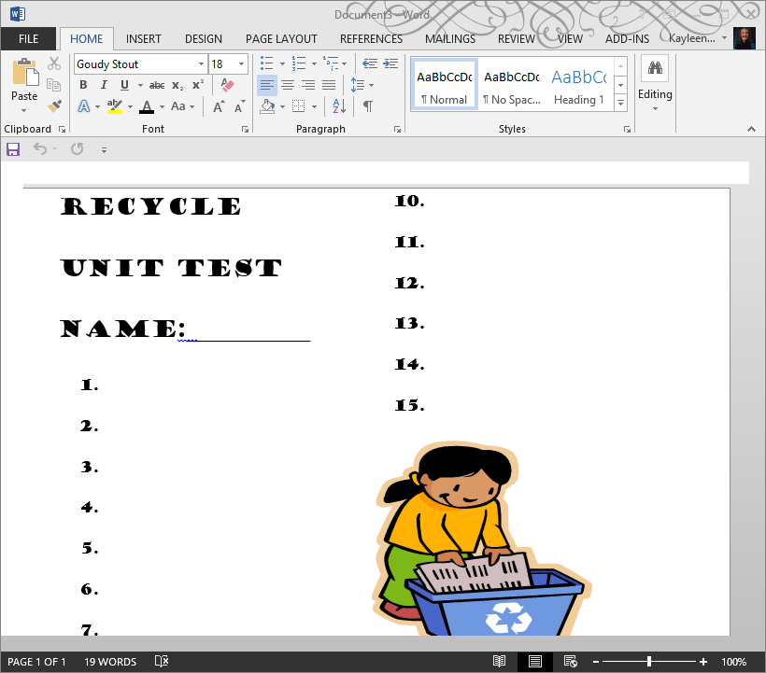

**Bulletin Board Sketch or picture**

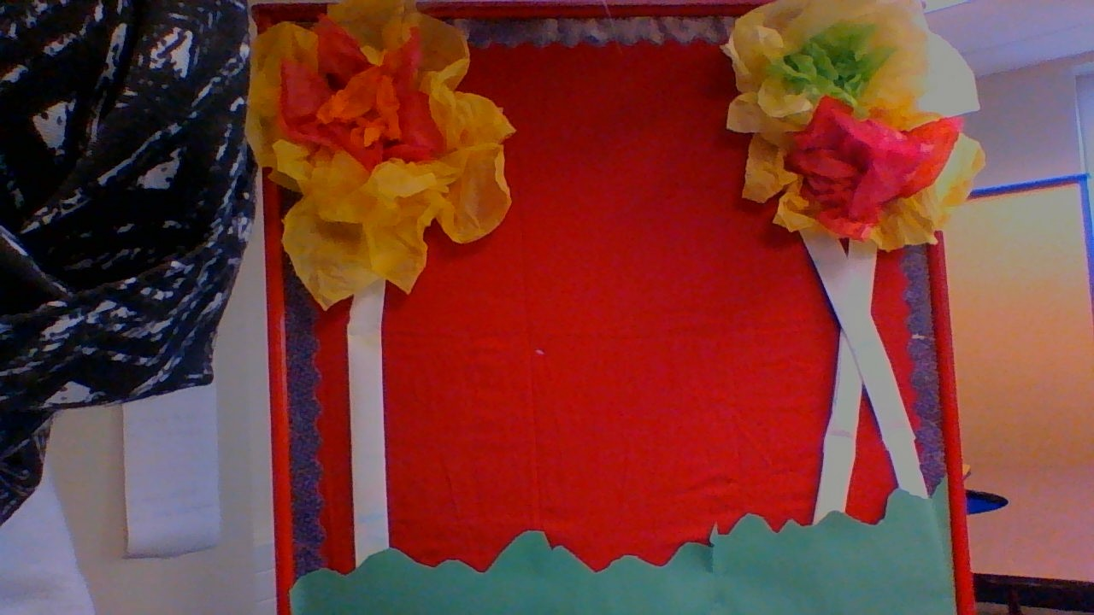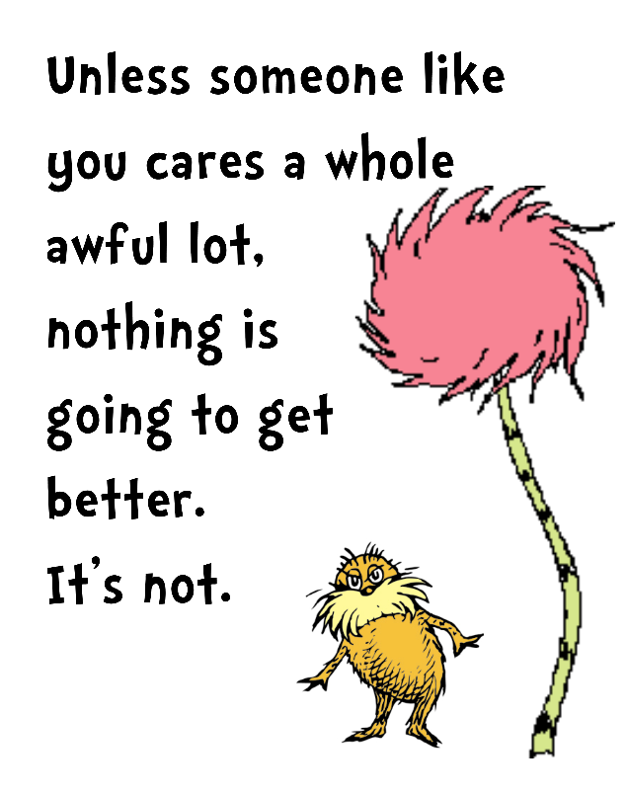

**References:**

**THE LORAX by Dr. Seuss**

**Pinterest.com**

**lakeshorelearning.com**

[**http://pbskids.org/sid/cleansup.html**](http://pbskids.org/sid/cleansup.html)

[*http://www.scholastic.com/teachers/lesson-plan/my-home*](http://www.scholastic.com/teachers/lesson-plan/my-home)

[*https://www.youtube.com/watch?v=qKfed5m0pOc*](https://www.youtube.com/watch?v=qKfed5m0pOc)

**Unit 2: Overall overview:**

Over the course of doing operation SMART, it really has been a great experience for me and great opportunity for me to work with the age group I set my goal to work with; kindergarten and first grade.

Through this experience I learned how to deal with students that had excellent behavior and also students who did not want to behave. Writing the lesson plans were not to hard once I got started on them. Although coming up with an activity that will fit the age group I was working with was a challenge. I wanted to make sure I adjusted the activity so that it was easier to understand and follow for when my students had to do it. I feel like operation SMART really taught me how to write it in the summative and formative way. I mainly chose to do formative assessment because it was easier for me to fit it into each of the lessons through asking questions and having my students use discussion with each other to review.

I know that there is room for improvement always when teaching. There were a lot of things I could have done better like teaching a lesson in a different way the kids could easily understand better, or another big change that I sought out was giving myself more time to do a lesson. As a teacher, I believe it is important to learn the kids learning styles so you can teach in a way that each student won’t get bored or want to sit out of an activity. I want to make sure that for the future I get every child involved in whatever activity I have planned for that particular day.